**Everyone’s courses:**

* Bachelor of business IBIS - CuNghi
* Bachelor of business IBIS - An
* Bachelor of science environmental science - zupidubadu
* Bachelor of science and bio tech - nurin
* Bachelor of computer science - ragib

**Ideas:**

Environmental crisis(oil spills) and oil industry (water and air)

(how they are controlling to mitigate impact)!

(oil spills on marine life)(oil on air)

(oil industry)

**Tasks needed to be done:**

* 4-5 media articles (Nurin)

1.[https://theconversation.com/meagre-fines-wont-stop-oil-spills-but-cooperation-could-9294](https://theconversation.com/meagre-fines-wont-stop-oil-spills-but-cooperation-could-9294" \o "https://theconversation.com/meagre-fines-wont-stop-oil-spills-but-cooperation-could-9294" \t "_blank)

2. <https://theconversation.com/first-montara-then-deepwater-horizon-is-australia-protected-from-catastrophic-oil-spills-996>

3. <https://eandt.theiet.org/content/articles/2021/02/the-graphic-oil-pollution-in-ecuador/>

4. <https://www.kunc.org/environment/2021-08-09/a-colorado-oil-company-allegedly-caused-dozens-of-spills-and-leaks-now-its-headed-to-a-trial>

5. <https://news.mongabay.com/2020/10/more-than-470-oil-spills-in-the-peruvian-amazon-since-2000-report/>

+ Identify 3–5 major issues this business or industry is facing.

+ prepare not more than 12 slides including references(powerpoint presentation)

Points: (An) (see next page)

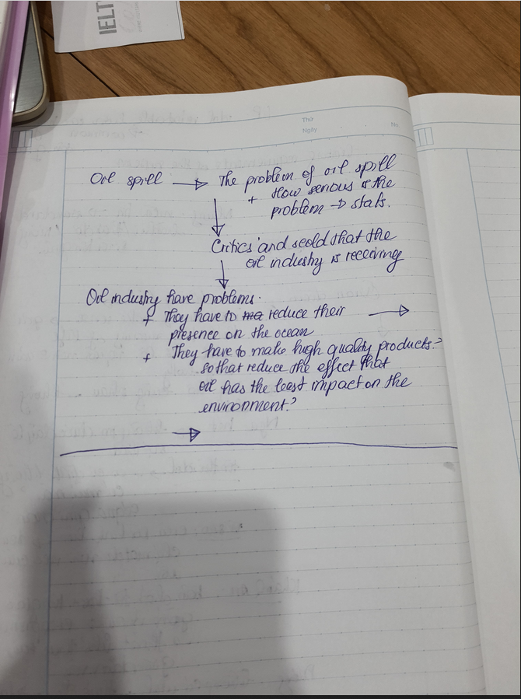

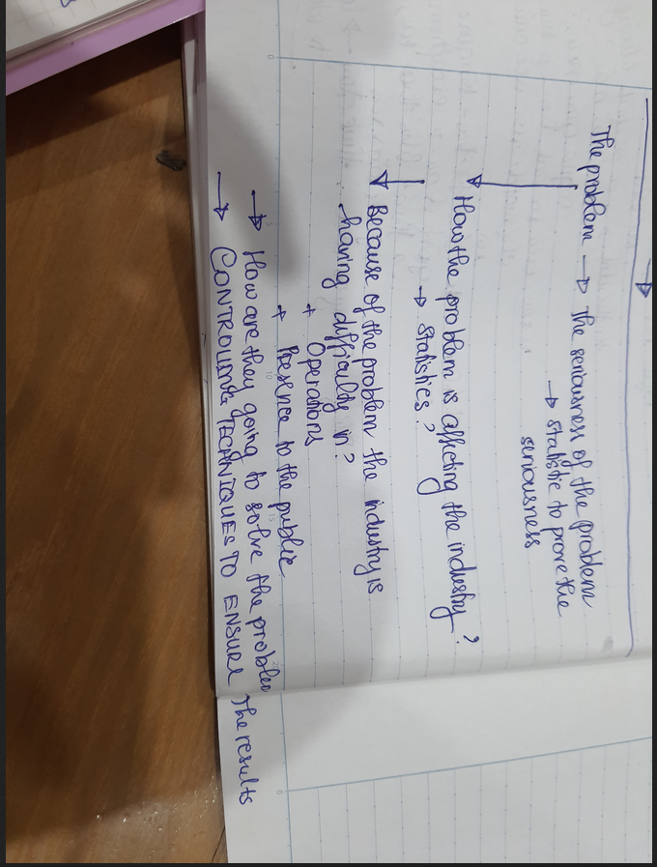

(current powerpoint format)

(Later on, she will give a project that a friend of her’s did last year)

* Please watch the "Leading and working in Teams" by Professor Amy Edmondson placed in Week 2 Modules (Self-direct tasks) and write 200-250 words to say how you used the strategies discussed in the video in preparing for the assessment.

Point: (CuNghi)

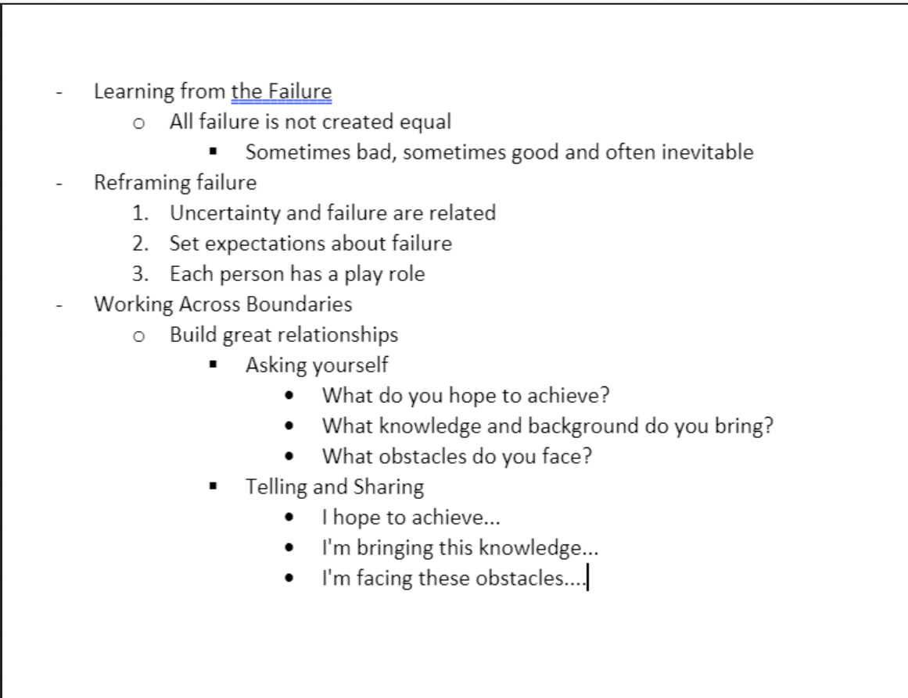

* the [Team Contribution Table.](https://swinburne.instructure.com/courses/37911/files/14923466?wrap=1)

(indivisual work)(collecting info for each people)

* at least two meeting agendas and meeting minutes for your group meetings

(zupidubabu) (done)

[some issues for oil industry: reputation, tax, loss of resource,]